[](https://www.c-sharpcorner.com/technologies/sql-server)

50 Important Queries In SQL Server

In this article I will explain some general purpose SQL queries. I think each developer should have knowledge of these queries. These queries are not related to any specific topic of SQL. But knowledge of such queries can solve some complex tasks and may be used in many scenarios, so I decided to write an article on these queries.

Query 1: Retrieve List of All Database

1. **EXEC** sp_helpdb

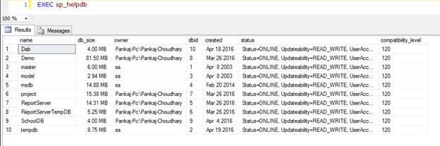

Query 2: Display Text of Stored Procedure, Trigger, View

1. **exec** sp_helptext @objname = 'Object_Name'

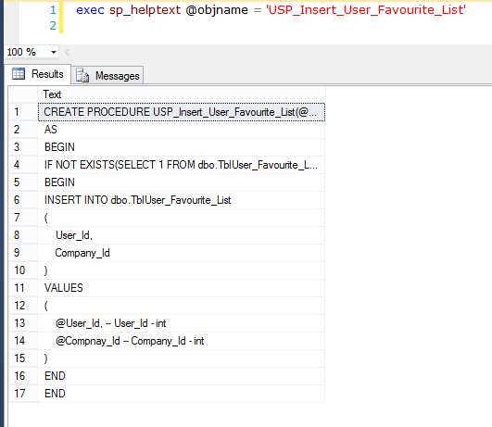

Query 3: Get All Stored Procedure Relate To Database

1. **SELECT** **DISTINCT** o.**name**, o.xtype
3. **FROM** syscomments c
5. **INNER** JOIN sysobjects o **ON** c.id=o.id
7. **WHERE** o.xtype='P'

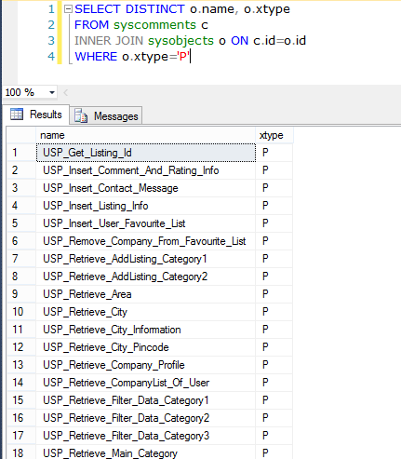

To retrieve the View use “V” instead of “P” and for functions use “FN.

Query 4: Get All Stored Procedure Relate To Table

1. **SELECT** **DISTINCT** o.**name**, o.xtype
3. **FROM** syscomments c
5. **INNER** JOIN sysobjects o **ON** c.id=o.id
7. **WHERE** c.TEXT LIKE '%Table_Name%' AND o.xtype='P'

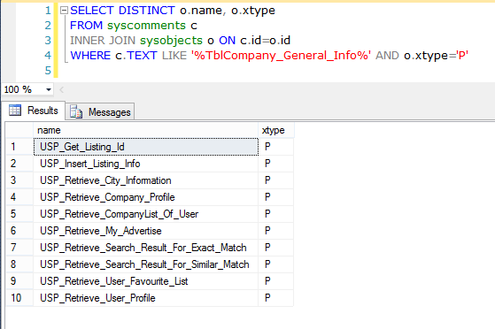

To retrieve the View use “V” instead of “P” and for functions use “FN.

Query 5: Rebuild All Index of Database

1. **EXEC** sp_MSforeachtable @command1="print '?' DBCC DBREINDEX ('?', ' ', 80)"
3. GO
5. **EXEC** sp_updatestats
7. GO

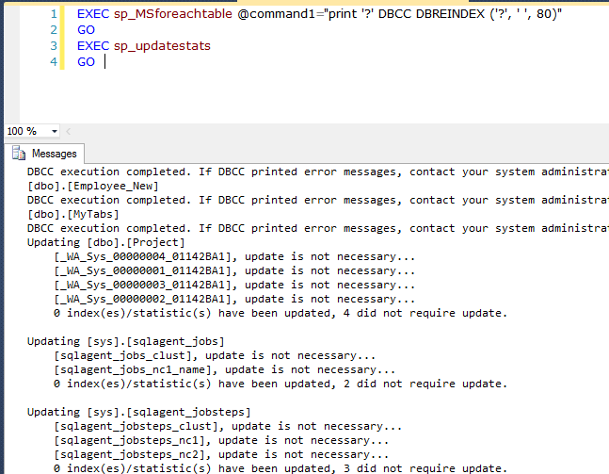

Query 6: Retrieve All dependencies of Stored Procedure

This query return all objects name that are using into stored procedure like table, user define function, another stored procedure.

1. ;**WITH** stored_procedures **AS** (
3. **SELECT**
5. oo.**name** **AS** table_name,
7. ROW_NUMBER() OVER(partition **by** o.**name**,oo.**name** **ORDER** **BY** o.**name**,oo.**name**) **AS** row
9. **FROM** sysdepends d
11. **INNER** JOIN sysobjects o **ON** o.id=d.id
13. **INNER** JOIN sysobjects oo **ON** oo.id=d.depid
15. **WHERE** o.xtype = 'P' AND o.**name** LIKE '%SP_NAme%' )
17. **SELECT** Table_name **FROM** stored_procedures
19. **WHERE** row = 1

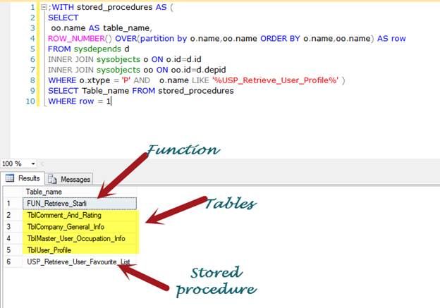

Query 7: Find Byte Size Of All tables in database

1. **SELECT** sob.**name** **AS** Table_Name,
3. SUM(sys.length) **AS** [Size_Table(Bytes)]
5. **FROM** sysobjects sob, syscolumns sys
7. **WHERE** sob.xtype='u' AND sys.id=sob.id
9. **GROUP** **BY** sob.**name**

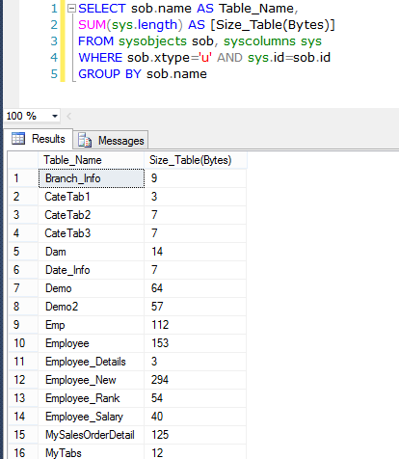

Query 8: Get all table that don’t have identity column

1. **SELECT**
3. TABLE_NAME **FROM** INFORMATION_SCHEMA.TABLES
5. **where**
7. Table_NAME NOT IN
9. (
11. **SELECT** **DISTINCT** c.TABLE_NAME **FROM** INFORMATION_SCHEMA.COLUMNS c
13. **INNER**
15. JOIN sys.identity_columns ic
17. **on**
19. (c.COLUMN_NAME=ic.**NAME**))
21. AND
23. TABLE_TYPE ='BASE TABLE'

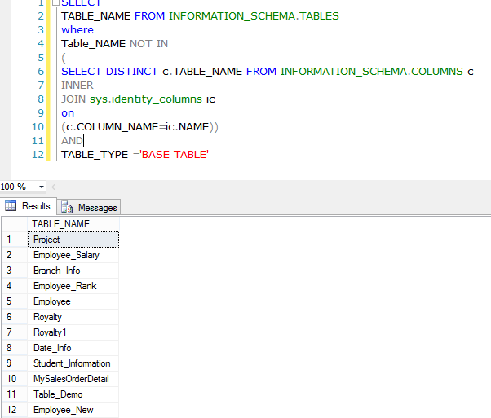

Query 9: List of Primary Key and Foreign Key for Whole Database

1. **SELECT**
3. **DISTINCT**
5. Constraint_Name **AS** [**Constraint**],
7. Table_Schema **AS** [**Schema**],
9. Table_Name **AS** [TableName] **FROM** INFORMATION_SCHEMA.KEY_COLUMN_USAGE
11. GO

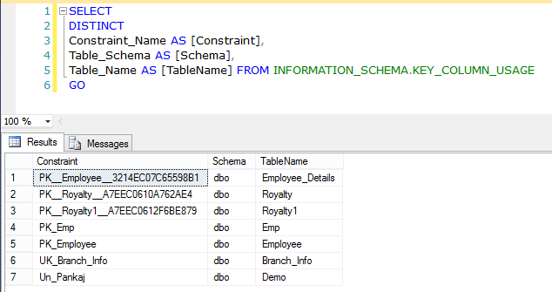

Query 10: List of Primary Key and Foreign Key for a particular table

1. **SELECT**
3. **DISTINCT**
5. Constraint_Name **AS** [**Constraint**],
7. Table_Schema **AS** [**Schema**],
9. Table_Name **AS** [TableName] **FROM** INFORMATION_SCHEMA.KEY_COLUMN_USAGE
11. **WHERE** INFORMATION_SCHEMA.KEY_COLUMN_USAGE.TABLE_NAME='Table_Name'
13. GO

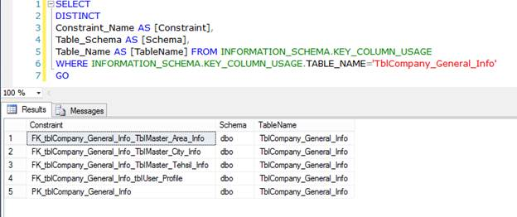

Query 11: RESEED Identity of all tables

1. **EXEC** sp_MSForEachTable '
3. IF OBJECTPROPERTY(object_id(''?''), ''TableHasIdentity'') = 1
5. DBCC CHECKIDENT (''?'', RESEED, 0)

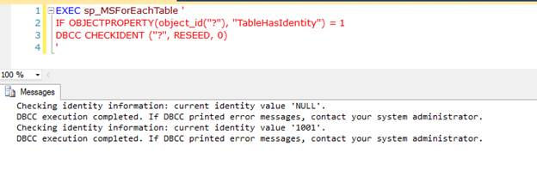

Query 12: List of tables with number of records

1. **CREATE** **TABLE** #Tab
3. (
5. Table_Name [**varchar**](**max**),
7. Total_Records **int**
9. );
11. **EXEC** sp_MSForEachTable @command1=' Insert Into #Tab(Table_Name, Total_Records) SELECT ''?'', COUNT(*) FROM ?'
13. **SELECT** * **FROM** #Tab t **ORDER** **BY** t.Total_Records **DESC**;
15. **DROP** **TABLE** #Tab;

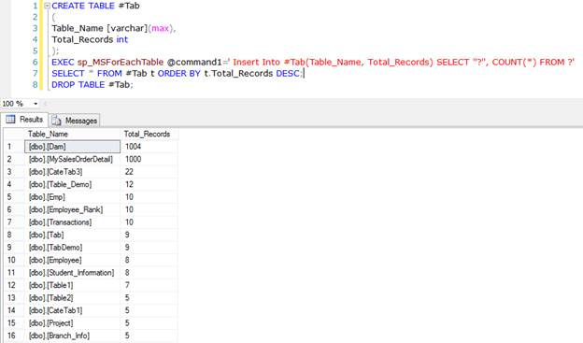

Query 13: Get the version name of SQL Server

1. **SELECT** @@VERSION **AS** Version_Name

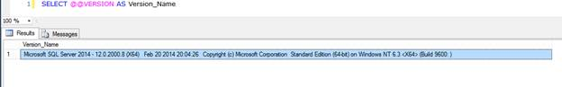

Query 14: Get Current Language of SQL Server

1. **SELECT** @@LANGUAGE **AS** Current_Language;

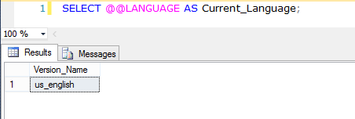

Query 15: Disable all constraints of a table

1. **ALTER** **TABLE** Table_Name NOCHECK **CONSTRAINT** ALL

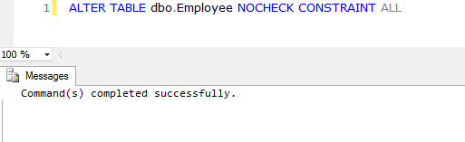

Query 16: Disable all constraints of all tables

1. **EXEC** sp_MSForEachTable 'ALTER TABLE ? NOCHECK CONSTRAINT ALL'

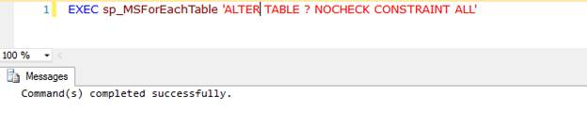

Query 17: Get Current Language Id

1. **SELECT** @@LANGID **AS** 'Language ID'

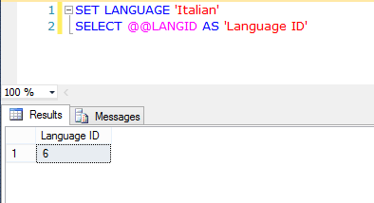

Query 18: Get precision level used by decimal and numeric as current set in Server

1. **SELECT** @@MAX_PRECISION **AS** 'MAX_PRECISION'

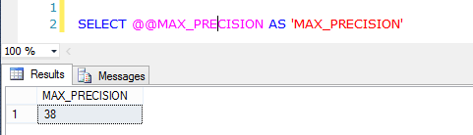

Query 19: Return Server Name of SQL Server

1. **SELECT** @@SERVERNAME **AS** 'Server_Name'

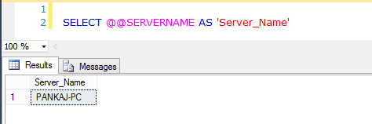

Query 20: Get name of register key under which SQL Server is running

1. **SELECT** @@SERVICENAME **AS** 'Service_Name'

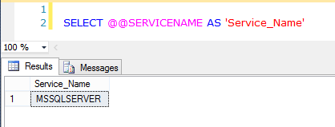

Query 21: Get Session Id of current user process

1. **SELECT** @@SPID **AS** 'Session_Id'

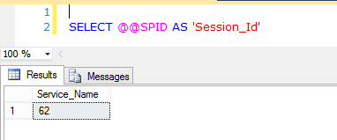

Query 22: Get Current Value of TEXTSIZE option

1. **SELECT** @@TEXTSIZE **AS** 'Text_Size'

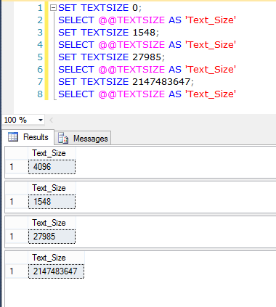

Query 23: Retrieve Free Space of Hard Disk

1. **EXEC** master..xp_fixeddrives

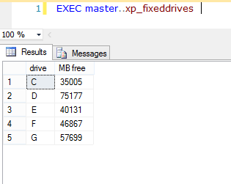

Query 24: Disable a Particular Trigger

**Syntax**

1. **ALTER** **TABLE** Table_Name DISABLE **TRIGGER** Trigger_Name

**Example**

1. **ALTER** **TABLE** Employee DISABLE **TRIGGER** TR_Insert_Salary

Query 25: Enable a Particular Trigger

**Syntax**

1. **ALTER** **TABLE** Table_Name ENABLE **TRIGGER** Trigger_Name

**Example**

1. **ALTER** **TABLE** Employee ENABLE **TRIGGER** TR_Insert_Salary

Query 26: Disable All Trigger of a table

We can disable and enable all triggers of a table using previous query, but replacing the "ALL" instead of trigger name.  
  
**Syntax**

1. **ALTER** **TABLE** Table_Name DISABLE **TRIGGER** ALL

**Example**

1. **ALTER** **TABLE** Demo DISABLE **TRIGGER** ALL

Query 27: Enable All Trigger of a table

1. **ALTER** **TABLE** Table_Name ENABLE **TRIGGER** ALL

**Example**

1. **ALTER** **TABLE** Demo ENABLE **TRIGGER** ALL

Query 28: Disable All Trigger for database

Using sp_msforeachtable system stored procedure we enable and disable all triggers for a database.

**Syntax**

1. Use Database_Name
3. **Exec** sp_msforeachtable "ALTER TABLE ? DISABLE TRIGGER all"

**Example**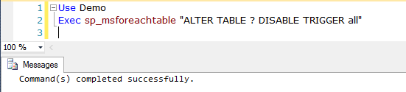

Query 29: Enable All Trigger for database

1. Use Demo
3. **Exec** sp_msforeachtable "ALTER TABLE ? ENABLE TRIGGER all"

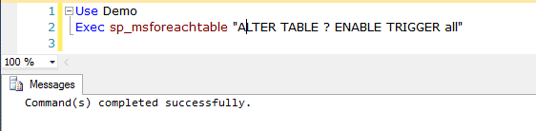

Query 30: List of Stored procedure modified in last N days

1. **SELECT** **name**,modify_date
3. **FROM** sys.objects
5. **WHERE** type='P'
7. AND DATEDIFF(D,modify_date,GETDATE())< N

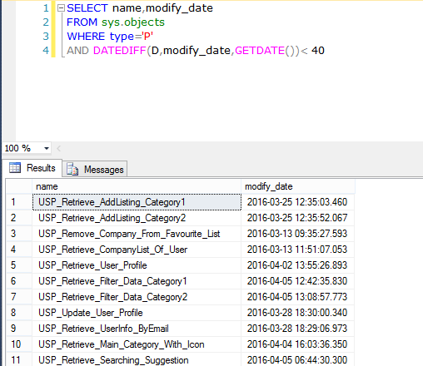

Query 31: List of Stored procedure created in last N days

1. **SELECT** **name**,sys.objects.create_date
3. **FROM** sys.objects
5. **WHERE** type='P'
7. AND DATEDIFF(D,sys.objects.create_date,GETDATE())< N

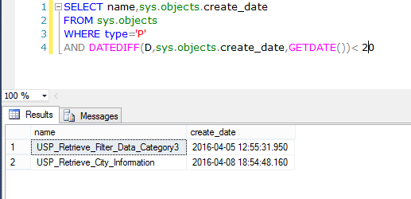

Query 32: Recompile a stored procedure

1. **EXEC** sp_recompile'Procedure_Name';
3. GO

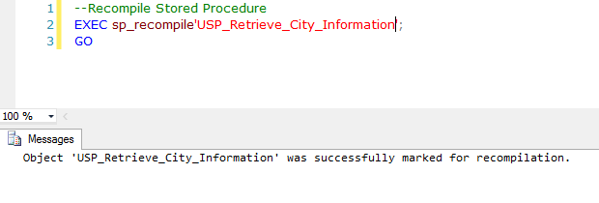

Query 33: Recompile all stored procedure on a table

1. **EXEC** sp_recompile N'Table_Name';
3. GO

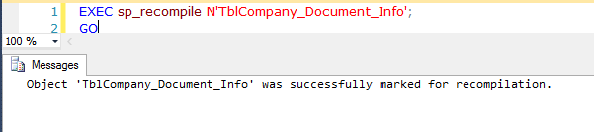

Query 34: Get all columns of a specific data type

1. **SELECT** OBJECT_NAME(c.OBJECT_ID) **as** Table_Name, c.**name** **as** Column_Name
3. **FROM** sys.columns **AS** c
5. JOIN sys.types **AS** t **ON** c.user_type_id=t.user_type_id
7. **WHERE** t.**name** = 'Data_Type'

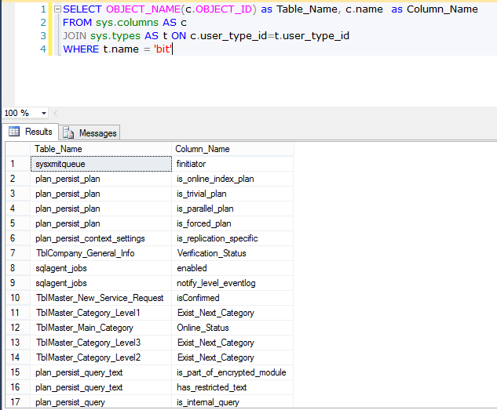

Query 35: Get all Nullable columns of a table

1. **SELECT** OBJECT_NAME(c.OBJECT_ID) **as** Table_Name, c.**name** **as** Column_Name
3. **FROM** sys.columns **AS** c
5. JOIN sys.types **AS** t **ON** c.user_type_id=t.user_type_id
7. **WHERE** c.is_nullable=0 AND OBJECT_NAME(c.OBJECT_ID)='Table_Name'

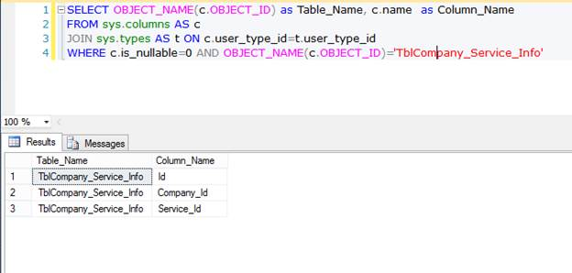

Query 36: Get All table that don’t have primary key

1. **SELECT** **name** **AS** Table_Name
3. **FROM** sys.tables
5. **WHERE** OBJECTPROPERTY(OBJECT_ID,'TableHasPrimaryKey') = 0
7. **ORDER** **BY** Table_Name;

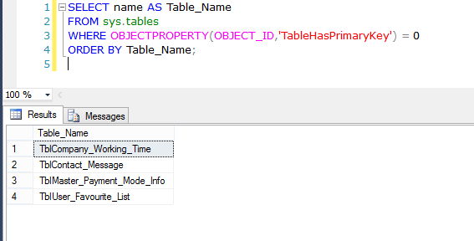

Query 37: Get All table that don’t have foreign key

1. **SELECT** **name** **AS** Table_Name
3. **FROM** sys.tables
5. **WHERE** OBJECTPROPERTY(OBJECT_ID,'TableHasForeignKey') = 0
7. **ORDER** **BY** Table_Name;

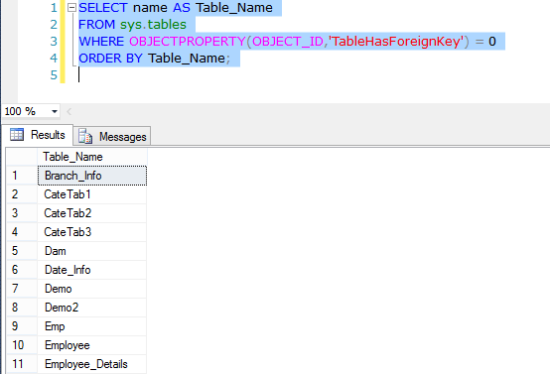

Query 38: Get All table that don’t have identity column

1. **SELECT** **name** **AS** Table_Name
3. **FROM** sys.tables
5. **WHERE** OBJECTPROPERTY(OBJECT_ID,'TableHasIdentity') = 0
7. **ORDER** **BY** Table_Name;

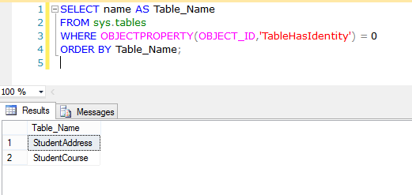

Query 39: Get First Date of Current Month

1. **SELECT** CONVERT(**VARCHAR**(25),DATEADD(DAY,-(DAY(GETDATE()))+1,GETDATE()),105) First_Date_Current_Month;

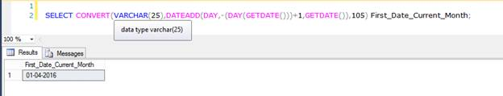

Query 40: Get last date of previous month

1. **SELECT** CONVERT(**VARCHAR**(25),DATEADD(DAY,-(DAY(GETDATE())),GETDATE()),105) Last_Date_Previous_Month;

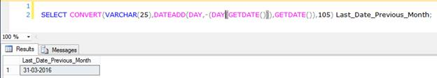

Query 41: Get last date of current month

1. **SELECT** CONVERT(**VARCHAR**(25),DATEADD(DAY,-(DAY(GETDATE())), DATEADD(MONTH,1,GETDATE())),105) Last_Date_Current_Month;

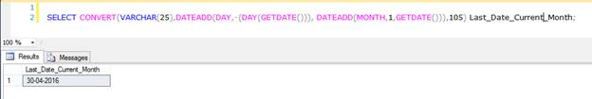

Query 42: Get first date of next month

1. **SELECT** CONVERT(**VARCHAR**(25),DATEADD(DAY,-(DAY(GETDATE())), DATEADD(MONTH,1,GETDATE())+1),105) First_Date_Next_Month;

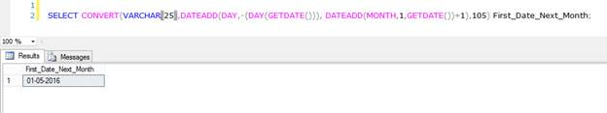

Query 43: Swap the values of two columns

1. **UPDATE** Table_Name **SET** Column1=Column2, Column2=Column1

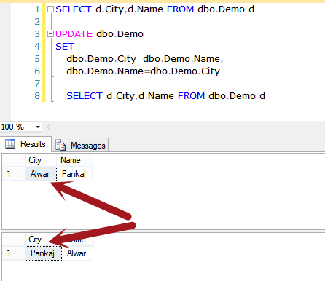

Query 44: Remove all stored procedure from database

1. **Declare** @Drop_SP Nvarchar(**MAX**)
3. **Declare** My_Cursor **Cursor** **For** **Select** [**name**] **From** sys.objects **where** type = 'p'
5. **Open** My_Cursor
7. **Fetch** **Next** **From** My_Cursor **Into** @Drop_SP
9. While @@FETCH_STATUS= 0
11. **Begin**
13. **Exec**('DROP PROCEDURE ' + @Drop_SP)
15. **Fetch** **Next** **From** My_Cursor **Into** @Drop_SP
17. **End**
19. **Close** My_Cursor
21. **Deallocate** My_Cursor

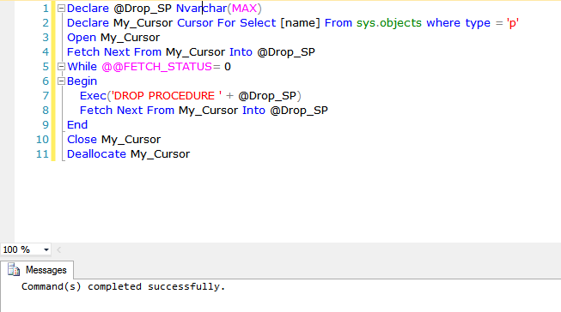

Query 45: Remove all views from database

1. **Declare** @Drop_View Nvarchar(**MAX**)
3. **Declare** My_Cursor **Cursor** **For** **Select** [**name**] **From** sys.objects **where** type = 'v'
5. **Open** My_Cursor
7. **Fetch** **Next** **From** My_Cursor **Into** @Drop_View
9. While @@FETCH_STATUS = 0
11. **Begin**
13. **Exec**('DROP VIEW ' + @Drop_View)
15. **Fetch** **Next** **From** My_Cursor **Into** @Drop_View
17. **End**
19. **Close** My_Cursor
21. **Deallocate** My_Cursor

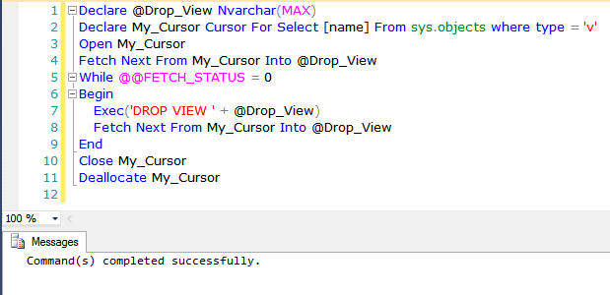

Query 46: Drop all tables

1. **EXEC** sys.sp_MSforeachtable @command1 = 'Drop Table ?'

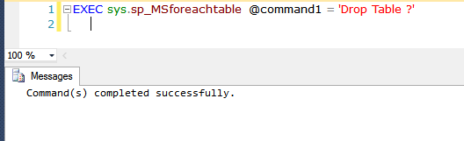

Query 47: Get information of tables’ columns

1. **SELECT** * **FROM** INFORMATION_SCHEMA.COLUMNS
3. **WHERE** INFORMATION_SCHEMA.COLUMNS.TABLE_NAME=’Table_Name’

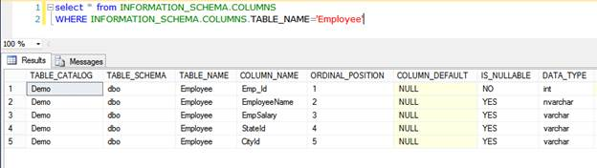

Query 48: Get all columns contain any constraints

1. **SELECT** TABLE_NAME,COLUMN_NAME,CONSTRAINT_NAME **FROM** INFORMATION_SCHEMA.CONSTRAINT_COLUMN_USAGE

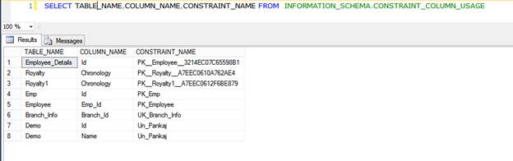

Query 49: Get all tables that contain a view

1. **SELECT** * **FROM** INFORMATION_SCHEMA.VIEW_TABLE_USAGE

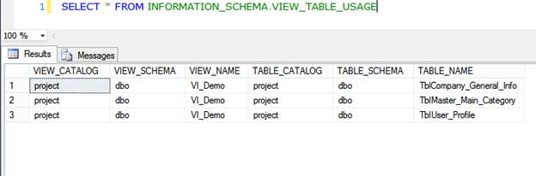

Query 50: Get all columns of table that using in views

1. **SELECT** * **FROM** INFORMATION_SCHEMA.VIEW_COLUMN_USAGE

